

**Submitted By:**

**Uqba Gulzar**

**Submitted To:**

**Engr. Muhammad Shehzad**

**Reg No:**

**2023-BSE-067**

**Section:**

**BSE-IVB**

**Department:**

**Software Engineering**

**Course Title:**

**SDA**

**LAB 02 part-II:**

## **Use Case Diagram for BATS**

## **Actors:**

* **Teller**
* **ATM**
* **Junior Clerk**
* **Client**

**Use Cases:**

* Open Account
* Account Statements
* Close Account
* Withdraw Money
* Transfer Money
* Record Transactions

**Use Case Diagram:**

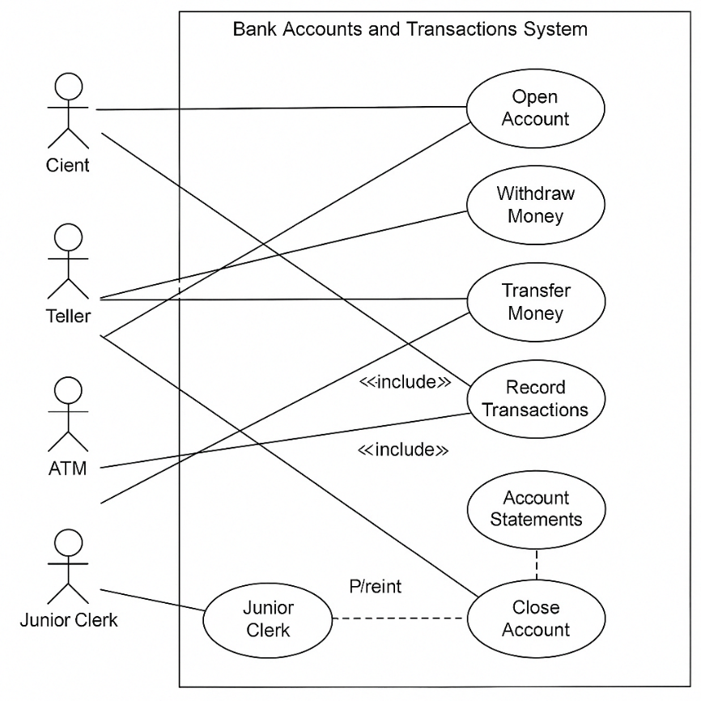

| **Actor** | **Use Cases** |
| --- | --- |
| Teller | Deposit, Withdraw, Transfer, Open Account, Close Account |
| ATM | Record Transactions |
|  |  |
| Junior Clerk | Post Statement |
| Client | Open Account, Record Transactions |